Chapter 19, Problem 29.

In the bridge circuit of Fig.19.87, I₁ = 10 A and I₂ = -4A.

a) Find V₁ and V₂ using y parameters.
b) Confirm the results in part (a) by direct circuit analysis.

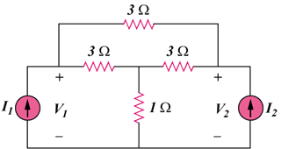

Figure 19.87
For Prob. 19.29.

